

**MASENO UNIVERSITY**

**SCHOOL OF COMPUTING AND INFORMATICS**

DEPARTMENT OF INFORMATION TECHNOLOGY

**UNIT CODE: CIT 309**

**UNIT NAME: IT PROJECT II**

**Waste Management System**

**BY**

**TITUS OWUOR: CI/00093/018**

**PROJECT PROTOTYPE IMPLEMENTATION SUBMITTED TO THE SCHOOL OF COMPUTING AND INFORMATICS IN PARTIAL FULFILLMENT REQUIREMENTS FOR THE AWARD OF THE DEGREE BACHELOR OF SCIENCE IN INFORMATION TECHNOLOGY.**

**JUNE,2022**

**MASENO UNIVERSITY**

**P.O. BOX PRIVATE BAG**

**MASENO, KENYA**

# **DECLARATION**

I hereby declare that this project proposal is my original work and has not been submitted before for any academic award either in this institution or other institution of higher learning for academic publication or any other purpose. I have followed the guidelines provided by the university in authoring this report.

Signature_________________________

Date_____________________________

Registration No: CI/00093/018

Name: **Titus Ooko Owuor**

I hereby certify that this project proposal has been submitted for examination with my approval as the project supervisor.

Signature_____________________

Date_________________________

Project Supervisor:

**Dr. Muhambe Mukisa**

# **DEDICATION**

Primarily, I wish to express my gratitude to the almighty God for giving me strength and good health during this time of pandemics.

Secondly, I dedicate this report to my family who has toiled so hard for me to be in an institution of higher learning, for all their love, support, and attention have made it possible for me to make it up to this point.

To my university supervisor Dr. Muhambe Mukisa, I appreciate him a lot for his commitment and guidance throughout the project writing.

To all my friends for morally supporting me in all circumstances and ensuring that I succeeded in writing this proposal.

# **ACKNOWLEDGEMENT**

The success of this project proposal writing took the effort, support, and guidance of several people whom I thank. Special thanks, appreciation, and heartfelt gratitude to the Almighty God for granting me good health, His guidance, grace, wisdom, and strength.

My sincere gratitude to my supervisor Mr. Muhambe for his unreserved guidance and support towards the successful completion of writing this project proposal.

I would also like to offer much appreciation to my family for their prayers, support, and guidance throughout my study.

I pay tribute to the Maseno University school of computing and informatics, department of information technology staff for their constructive training and knowledge imparted to me.

My special thanks to my friends and colleagues for their support throughout the project. This project would not have been a success without all their support.

# 

# 

# 

# 

# **ABSTRACT**

A large share of the Kenya’s urban population live in slum areas affected by waste pollution. Every waste generated and collected which stands at approximately two thousand tons ends up in local dumpsites in towns or villages. For instance, the Dandora dumpsite in Nairobi. The Nairobi River runs along with the site. The river is choked and contaminated with waste from the dumpsite. This has culminated in health and environmental consequences for residents and slums in the area who are dependent on the river for domestic and other uses. Evidence shows that water has high levels of heavy metals and is polluted by used syringes, plastics, rubber, lead paint-treated wood, and chemicals that are found in the river. This presents dangers to the environment and health of riverine communities that use water for irrigation and domestic uses (Kinuthia, 2015). High-level elements such as mercury and cadmium among others have been detected at the dumpsite (Barczak, Thumbi & Ogola, 2015).

To solve the above-stated shortcomings, a smart city model should be forged, planned out. An advanced open EMIS system that can perform web scraping across the internet and common social media platforms should be put in place to collect, analyze, visualize, and disseminate the information to both the county and national governments on current local existing industries, their end waste product, and suggest secure ways of disposing of off the waste if it cannot be recycled but most importantly identify related industries that may utilize as part of their raw material , should then be developed to integrate and manage different modules in the smart city model to realize a clean and healthy urban life for all levels of social classes in the urban and rural areas. The information provided by the system also helps set up related industries close to each other to avoid transport costs for transferring the waste from one company to another that uses it as raw material. For instance, the waste material produced at the Muhoroni sugar company can be used by fertilizer manufacturing companies as part of their inputs. A biogas power plant can also be set up in the area to utilize part of the waste from the industries to generate biogas, an alternative source of energy instead of dumping the waste irresponsibly. This will help to raise the per capita income of the country and in turn raise living standards of the common citizen.

s

Table of Contents

DECLARATION 1

DEDICATION 2

ACKNOWLEDGEMENT 3

ABSTRACT 4

LIST OF TABLES 6

LIST OF FIGURES 7

CHAPTER 1: INTRODUCTION 9

1.1 Background to Study 9

1.2 Statement of the Problem 9

1.3 Study Objectives 10

1.3.1 Overall/Main Objective 10

1.3.2 Specific Objectives 10

1.4 Research Questions 10

1.5 Significance 10

1.6 Limitations 10

1.7 Assumptions 11

CHAPTER 2: LITERATURE REVIEW 12

2.1 Existing Web Scraping Systems 12

2.1.0 Import.io 12

2.1.1 Pros: 12

2.1.1 Cons: 12

2.2 Proposed Web Scraping System 14

2.2.1 System Architecture 14

2.2.2 Proposed system advantages 15

2.2.3 Conclusion 15

CHAPTER 3: METHODOLOGY 16

3.1 INTRODUCTION 16

3.2 Research Design 16

3.3 Targeted Population 17

3.4 Sample Size & Justification 17

3.5 Choice of Proposed System Development Methodology 17

3.6 Results Analysis & Presentation 18

3.7 Ethical Issues 21

CHAPTER FOUR: SYSTEM ANALYSIS, DESIGN & DEVELOPMENT 22

4.1 Requirements Gathering & Analysis 22

4.1.1 Functional Requirements 22

4.1.2 Non-Functional Requirements 23

4.2 System Design & Modeling Tools 23

4.2.1 Use Case Diagrams 24

4.2.2 Activity Diagram 24

4.2.3 Class Diagrams 26

4.2.4 Sequence Diagram 27

4.2.5 ERD 28

4.2.6 DFD 28

4.2.7 User Interface Prototypes 28

4.2.8 Database Design 31

4.3 Resources 32

4.4 Development Environment: Hardware & Software Platform 32

4.5 Systems Testing & Validation 34

CONCLUSION 34

APPENDICES 37

APPENDIX 1 37

APPENDIX 2 38

Research questions 38

APPENDIX 3 42

# 

# 

# **LIST OF TABLES**

Table 1 Project Budget 43

# 

# **LIST OF FIGURES**

Figure 0-1 Figure 10: Waste management problems analysis pie chart 19

Figure 0-1 4 Use Case Diagrams 24

Figure 0-2 1 Class Diagrams 27

Figure 4 0 Sequence Diagram 28

Figure 5 Database Design 32

# 

# **CHAPTER 1: INTRODUCTION**

## 1.1 Background to Study

Most Enterprise Resource Planning software available in the market like Zoho and Zen Desk majorly focus on providing resource planning for the internal resources of an industry rather than providing additional information on related industries that may utilize the company’s waste, and proper waste management.

The EMIS software, however, will work with google business APIs, web bots and city resource management systems to identify different industries in the country, their waste products and inputs. The data collected will useful in decision making, for example, setting up a certain group of industries close to each other and use mutual interdependence between them to manage waste create more gods and services at much cheaper costs since transport costs are eliminated. The EMIS will collect data through web-scraping data concerning end waste products for different industry websites from the internet in Kenya, suggesting industries that depend on each other’s waste as its inputs to encourage responsible consumption and waste management.

The EMIS web platform will be easy to use as an authorized user only needs to log in, provide specific links to certain industrial websites they are interested in and click on the **“initiate data mining process” button** from the system interface. The software will scrape, analyze, and visualize relevant data from the selected sites which can then be fed to ERP software for better planning, production, and allocation of resources.

## 1.2 Statement of the Problem

Proper waste management system is a major deficiency in most to most townships in Kenya. It is difficult for industries to properly dispose of their waste.

## 1.3 Study Objectives

### 1.3.1 Overall/Main Objective

● To eliminate irresponsible disposal of industrial waste.

### 1.3.2 Specific Objectives

● To develop an advanced Waste Management system with the capability to scrap the web and identify end waste products of different industries in Kenya.

● To promote better utilization and recycling of waste products from industries in order to maximize income generation and avoid environmental degradation.

## 1.4 Research Questions

● How can local industries utilize waste products from other related industries to generate income and avoid environmental degradation?

● Is there a better way of utilizing industrial waste as inputs of other related industries?

## 1.5 Significance

This study aims at providing vivid solutions to the drawbacks experienced in industrial waste management. The EMIS software is therefore of great significance to the country if implemented as the above-stated problem depends solely on the information mined by the system to aid investors and companies or industries on where best to set up, when, and where to attain cheap raw material without enduring transport costs. This in turn helps to avoid road damage through heavy raw material/waste product transportation to concerned industries. The software also helps existing industries to make extra income by selling their waste to other industries hence raising per-capita income for the country.

## 1.6 Limitations

● The data to be mined and analyzed by the proposed system will depend solely on the integrity and trustworthiness of data borrowed from web pages on the internet. In case of any misleading information being obtained, wrong conclusions may be drawn from the information which is a limiting factor.

● Some websites install software that hinders the operation of web crawlers. This will slow down the entire process.

## 1.7 Assumptions

● All industries in Kenya have a website hosted on the internet with detailed information about their expertise and production schemes.

● All company websites in Kenya allow web scraping.

● Information retrieved from data mining is genuine

# **CHAPTER 2: LITERATURE REVIEW**

This study aims at reviewing the existing systems in the outside world and making a close comparison with the proposed system. The study considers the gaps available in the existing systems and develops strengths of the proposed system from them.

## 2.1 Existing Web Scraping Systems

### 2.1.0 [Import.io](https://www.trustradius.com/products/import-io/reviews)

Import.io provides a way for anyone with web data to extract information with a very user-friendly, intuitive, and interactive interface. The cloud-based scraping platform can structure data found behind images, login screens, and hundreds of web pages with absolutely no coding. Monitoring website changes and the ability to integrate with a few reporting tools and apps make it a great option for enterprises with a pressing scraping need.

### 2.1.1 Pros:

● A simple and lightweight UI that works well for non-coders looking to build their list of prospects or track price changes.

● It is a viable option for scraping at a reasonable speed efficiently from different websites concurrently.

### 2.1.1 Cons:

● It is expensive to use

**2.1.2 Dexi.io**

Dexi.io is another visually stunning extraction automation tool positioned for commercial purposes and is available as a hassle-free browser app. Dexi has provisions for creating robots that can work as an extractor or crawler or perform ETL data cleansing tasks after extraction in the form of Dexi Pipes. The powerful scraping tool gives suggestions after data selection on the web page for intelligent extraction features that resolve pagination issues, perform extraction in a loop, and take screenshots of web pages.

**2.1.2.1 Pros:**

● There are no tough set-up routines that you must follow. Sign up and the browser app opens for you to create your robot. Their awesome support team will help you with the bot creation in case you hit a roadblock.

● For a commercial tool, it is a bit affordable

**2.1.2.2 Cons:**

● The concept of an add-on in Dexi.io, though attractive at first, becomes a handful to maintain as the add-on increases and so does the cost for any add-on in the store.

● There are slight murmurs and grunts about the product documentation

**2.1.3 Octoparse**

The blue Octo promises data at your fingertips with no programming at all. It has an intuitive point-and-click interface that supports infinite scrolling, log-in authentication, multi-format data export and supports unlimited pages per crawl in its free plan

**2.1.3.1 Pros:**

● Scheduled crawling features and provision for unlimited web pages per crawl make it an ideal choice for price monitoring scenarios.

● Features provided in their free plan are more than enough if you are looking for an effective one-time, off-the-shelf solution with good user guide documentation. Also, precise extraction of data can be achieved with their in-built XPath and Regex tools.

**2.1.3.2 Cons:**

● Octoparse is yet to add pdf-data extraction and image extraction features (just image URL is fetched) so calling it a complete web data extraction tool would be a tall claim.

● Customer support is not great for the product and timely responses are not to be expected.

**2.1.4 [Parse Hub](https://www.parsehub.com/)**

A desktop app that offers a graphical interface to select and extract the data of your choice from JavaScript and AJAX pages as well and is supported by Windows, Mac OS X, and Linux. It can scrape through nested comments, maps, images, calendars, and pop-ups too. There is also a browser-based extension to launch your scrape instantly.

**2.1.4.1 Pros:**

● Parse Hub has a rich UI and pulls data from many tricky areas of a website, unlike other scrapers.

● Developers can play with Parse Hub's Restful API for good data access after they are happy with the one-off scrape.

**2.1.4.2 Cons:**

● Expensive to use.

● The speed at which scrape is performed needs to be vastly improved which also slows down the rate at which large volume scrape is done.

## 2.2 Proposed Web Scraping System

## 2.2.1 System Architecture

The researcher proposes an improved enterprise scraping software (EMIS) that is affordable and has improvised scraping and data analysis techniques. The objective is to avail a cheaper and more convenient way for both small and large businesses to be able to manage their waste efficiently and maximize income.

In the proposed implementation, an authorized user is able to login into the system and the system will initiate a web crawling bot which automatically begins data mining of selected target websites. The bot will collect data from the target websites and store it in the form of tuples and dictionaries for easy analysis. The tuples are then striped to get specific sensible information about waste product management. The system also identifies different industrial wastes and suggests possible related industries that can be established to consume the waste and produce other valuable goods instead of dumping the waste.

## 2.2.2 Proposed system advantages

● Cheaper compared to the available web scraping software available out there.

● Ability to visualize data in the form of graphs and charts for light reading.

● Ability to suggest proper waste industrial waste disposal and better resource utilization.

## 2.2.3 Conclusion

From the information gained from the literature as seen above, it is evident that most of the existing systems despite being so good in the scraping process are too expensive for local small businesses to afford besides lack a suggestion system for the best waste management practices. The proposed system solves this.

# **CHAPTER 3: METHODOLOGY**

## 3.1 INTRODUCTION

The chapter discusses in detail the choice of methodological and the research design process of the study. It has mainly relied on the philosophical stance and the research problem to guide on the methodological choice. More, specifically, it explains why the quantitative research approach is considered appropriate for the research. In addition, the chapter set the procedures to collect, analyze and report data. It has used separate procedures for the quantitative approach as it encompasses a distinct purpose to serve. Besides, the approaches implemented to enhance the validity and reliability of the studies are also explained in detail. Finally, the chapter defines procedural issues of the research including the timing, weighting, and integration decisions of the study along with pointing considerations for ethical issues.

## 3.2 Research Design

A research design is the ‘procedures for collecting, analyzing, interpreting and reporting data in research studies (Creswell & Plano Clark 2007, p.58). It is the overall plan for connecting the conceptual research problems with the pertinent (and achievable) empirical research. In other words, the research design sets the procedure for the required data, the methods to be applied to collect and analyze this data, and how all of this is going to answer the research question (Grey, 2014).

Research design is divided into two major approaches: qualitative research and quantitative research. Research design is not associated with any technique of data collection or any data (Akhtar, 2016). This work will encompass qualitative aspects of research design. Qualitative research was developed in the field of social sciences to allow researchers to study social and cultural phenomena. According to Fossey et.al, 2002; McGuirk and O'Neill, 2016, Qualitative research aims to address questions concerned with developing an understanding of the meaning and experience dimensions of humans’ lives and social worlds. According to the researchers, good qualitative research is usually dependent on whether the research participants’ subjective meanings, actions, and social contexts, as understood by them, are illuminated.

Qualitative data sources include observation and participation observations, interviews, researcher’s impressions, and reactions, questionnaires, texts, and documents. This study will use online survey questionnaires as the main qualitative research designs that will be used for analysis. However, questionnaires can be used as both quantitative and qualitative research design techniques (McGuirk & O'Neill, 2016). But this study will focus on the qualitative aspect of questionnaires. Original data will be collected and analyzed to provide a holistic understanding of the case.

## 3.3 Targeted Population

The research was based on Kenyan local industries, their customers, their production plans, and methods of disposing of waste and market research.

In addition, secondary research was done on the internet to gather more information about local industries. Internet research will solely depend on information posted on the company websites. Other forms of data collection like face-to-face interviews will not be applicable. Instead, the study will make use of online survey forms to collect data about the proposed system.

## 3.4 Sample Size & Justification

According to most researchers carrying out qualitative research, the adequacy of sample size is a key marker for the research’s quality. However, there is no consensus with respect to the exact size of a proper sample. The approximate number of responses were 20 to 100 per organization due to limited resources and time otherwise a large number could be adopted. The surveys were distributed evenly among counties to avoid biases.

## 3.5 Choice of Proposed System Development Methodology

The system development life cycle is a common methodology used in all most every organization, as the system development projects got bigger and the discipline of software engineering began to set some standards of its own a lot of methodologies have seen light and were put together by organizations seeking success according to their own measurement of success (Malik, Ahmad & Hussain, 2019).

The main purpose of system development is the enhancement of the productivity of the organization and the group of people working in that organization, as system development gets bigger, there was a need to systemize the process of system development and produce a set of steps that are required for any system development (Benzzine, 2022).

A system development methodology refers to the framework that is used to structure, plan, and control the process of developing an information system (Valcich& George, 2016). A wide variety of such frameworks have evolved over the years and each with its own recognized strengths and weaknesses. Therefore, one system development methodology is not necessarily suitable for use by all projects. Each of the available methodologies is best suited to specific kinds of projects, based on various technical, organizational, project, and team considerations. In this project, Agile methodology, particularly Scrum, was adopted. Agile has remained one of the most adopted system development methodologies that focus on delivery speed and continuous improvement of the product. Rather than treating requirements, design, and testing as large sequential steps, an agile model makes them all ongoing processes that require involvement from developers, management, and customers. According to Benzzine (2022) work is typically broken into 2–4week segments known as “sprints,” in which the responsible teams tackle the major needs of their customers and perform testing as they go.

## 3.6 Results Analysis & Presentation

The survey data was carefully cross-checked to detect errors and omissions, consistency, and completeness. The data collected was systematically arranged according to questionnaire codes to facilitate analysis. Each question was coded and labeled into a variable for entry and computation into IBM statistical package for social sciences (SPSS) version 23. Data were analyzed for descriptive statistics and presented in tables and pie charts. The following are the results of the study as directed by the research objectives.

1. Access how industries manage their resources especially waste products, methods used and effectiveness, and access if/whether over-production adds to industrial waste.

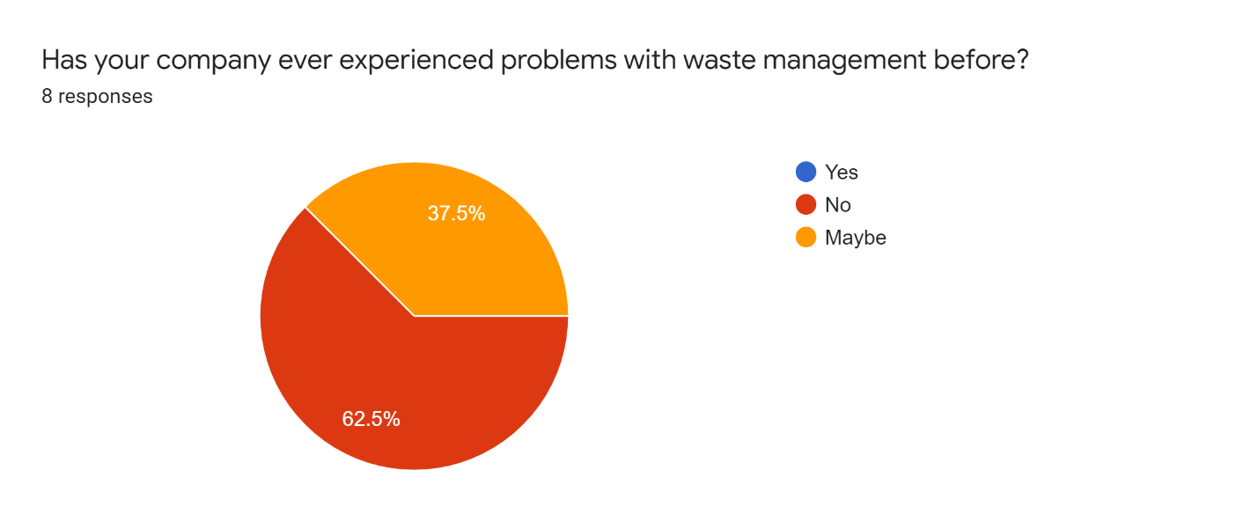

Figure -Figure 10: Waste management problems analysis pie chart

According to the pie chart, it is clear that 37.5% of the respondents are not aware that their company is experiencing waste management problems before or not. A bigger number, 67.5%, claim that their respective companies have not experienced problems with waste management.

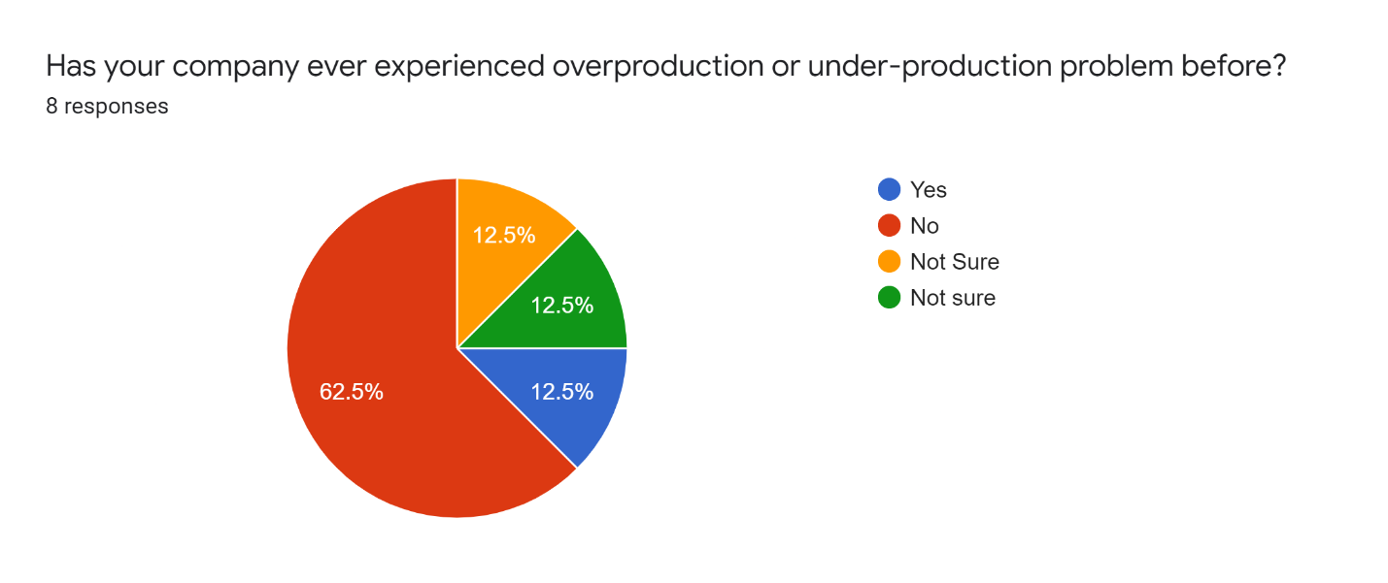

Figure 11: over-production

From the pie chart, it is deduced that most industries don’t experience over-production and it is likely not to lead to waste problems. 62.5% of industries in Kenya do not experience an overproduction problem while 12.5% experience the problem.

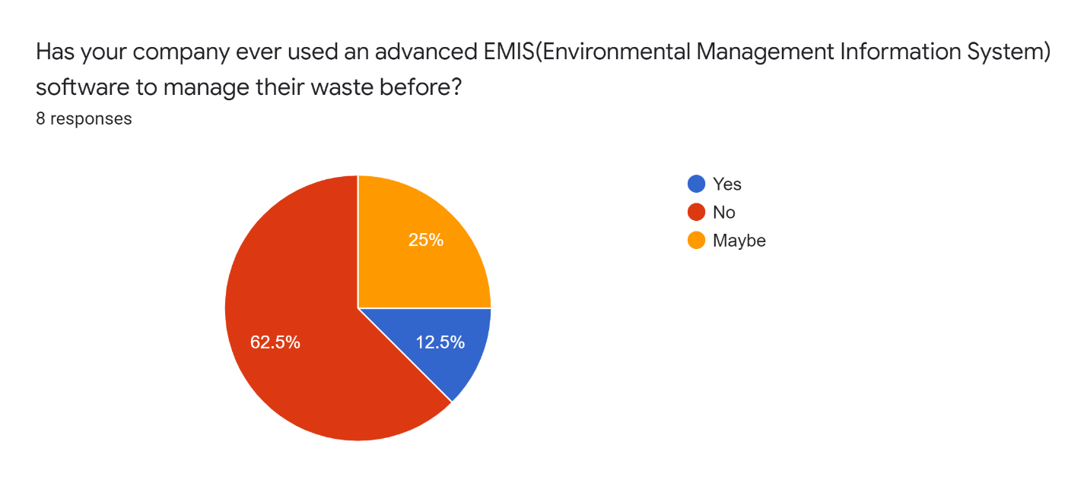

Figure 12: Accessing existing WMS

62.5% of the respondents’ respective companies do not use waste management systems. 25% of the respondents are not sure if their respective companies use EMIS while 12.5% are not sure.

1. Access the possibility of industries accepting the EMIS system if at all it is implemented and available for use.

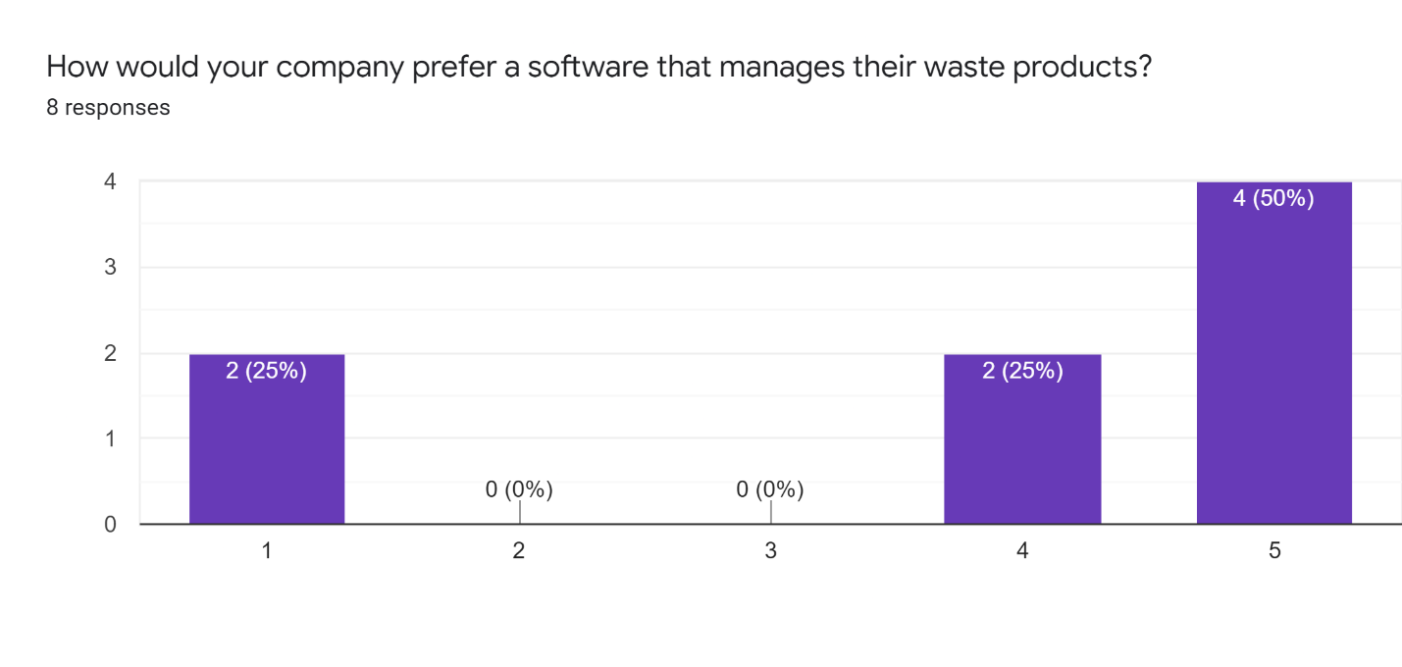

Figure 13: WMS preference bar graph

From the bar graph, it is easy to tell that 50% of the respondents are fully sure that their respective companies would prefer the EMIS system. 25% of them strongly believe that the software will be preferred while the other 25% are slightly negative about the idea.

## 3.7 Ethical Issues

Ethics is the study of value concepts such as ‘good,’ ‘bad,’ ‘right,’ ‘wrong,’ ‘ought’, applied to actions in relation to group norms and rules. Therefore, it deals with many issues fundamental to practical decision-making (Veatch, 1977). Computer software systems lie at the heart of modern decision making, including data/information storage and manipulation, data availability, and ‘alternatives’ formulation and selection. The data collected in the proposed system survey ensured that research ethics are observed. The researcher will request permission from the relevant research target institutions before supplying an online survey. Permission to conduct the study was obtained from the nearest industrial facility to conduct an online survey among its employees about ERPs and the state of production and market knowledge in the facility. During data collection, study participants were assured of the confidentiality of the information and responses they provided by signing a consent form. The respondents were free to withdraw from the study whenever they wanted.

# **CHAPTER FOUR: SYSTEM ANALYSIS, DESIGN & DEVELOPMENT**

System Analysis, Design, and Development presents a comprehensive, step-by-step approach for organizing, analyzing, designing, developing, verifying, and validating systems, products, and services. According to Wasson (2006), a successful system development requires the formulation and implementation of a sound technical strategy that accurately translates the user's operational needs into a physical solution to comply with their specifications and contract requirements.

## 4.1 Requirements Gathering & Analysis

Each requirements statement serves to specify and bound the deliverable system, product, or service to be developed or modified (Wasson, 2006). The prerequisite to developing requirements is to first identify what capability is required.

### 4.1.1 Functional Requirements

These are the requirements that the end-user specifically demands as basic facilities that the system should offer. All these functionalities need to be necessarily incorporated into the system as a part of the contract. These are represented or stated in the form of input to be given to the system, the operation performed, and the output expected. They are the requirements stated by the user which one can see directly in the final product. The following are the functional requirements of the system.

I. Users should be able to register and log in to the system.

II. Users should be able to access the dashboard on successful login

III. Users should be able to select target websites to perform data mining on and click on the confirm button to begin data mining.

IV. users should be able to access the different graphical data visualization web pages on successful completion of data mining and analysis

V. An admin should be able to login and manage users of the system and the whole platform itself.

### 4.1.2 Non-Functional Requirements

These are the quality constraints that the system must satisfy according to the project contract. The priority or extent to which these factors are implemented varies from one project to another.

**Usability**

The system will be easy to use by every user, and the system will have a simple and well-designed interface.

**Accessibility**

The Application will be made accessible to the users. Anyone will be able to use the system regardless of the location.

**Performance**

The performance of the application will be fast and efficient. The system should be available for users in real-time and always up to date.

**Availability**

The Application will operate 24/7.

**Security**

**Maintainability**

The application will be maintained to perform to the best of its ability.

**Extensibility and Scalability**

The application will be flexible enough to allow improvements for the future and should be able to adapt to any changes.

**Disaster Recovery**

The application will be able to recover from any problem and should back up data.

## 4.2 System Design & Modeling Tools

System design deals with modeling software systems. Modeling a system means identifying its main characteristics, states, and behaviors using a notation. Models are meant to simplify reality and promote understanding. Modeling in this project was achieved using UML, short for Unified Modeling Language. UML is a standardized modeling language consisting of an integrated set of diagrams, developed to help system and software developers for specifying, visualizing, constructing, and document the artifacts of software systems.

### 4.2.1 Use Case Diagrams

A use-case model describes a system's functional requirements in terms of use cases. It is a model of the system's intended functionality (use cases) and its environment (actors).

Figure -4 Use Case Diagrams

*Figure : Use Case Diagram*

User

Admin

### 4.2.2 Activity Diagram

These are graphical representations of workflows of stepwise activities and actions with support for choice, iteration, and concurrency. It describes the flow of control of the target system, such as exploring complex business rules and operations and describing the use case as well as the business process. In the Unified Modeling Language, activity diagrams are intended to model both computational and organizational processes.

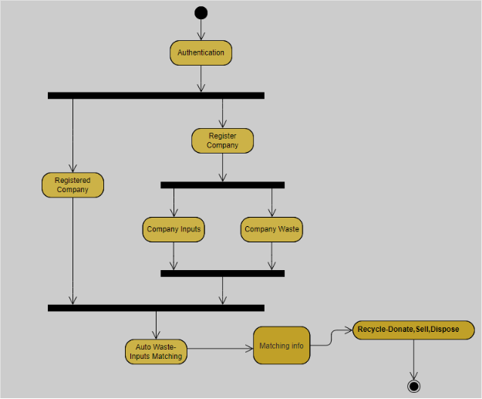

### 4.2.3 Class Diagrams

The class diagram is a central modeling technique that runs through all object-oriented methods. This diagram describes the types of objects in the system and various kinds of static relationships which exist between them. The following class diagram depicts the most essential objects that will be in the proposed software.

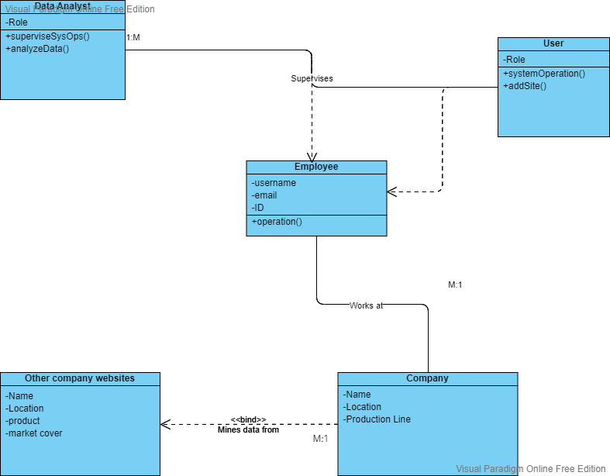

Figure -1 Class Diagrams

*Figure 3: Class Diagram*

### 4.2.4 Sequence Diagram

The Sequence Diagram models the collaboration of objects based on a time sequence. It shows how the objects interact with others in a particular scenario of a use case.

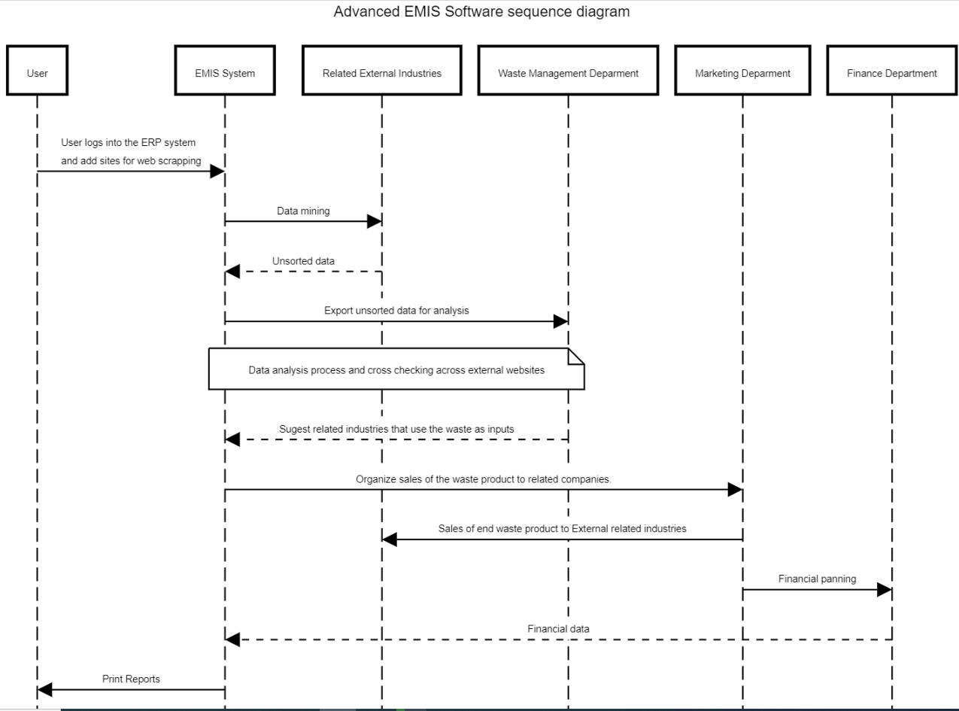

Figure 0 Sequence Diagram

4.2.6 DFD

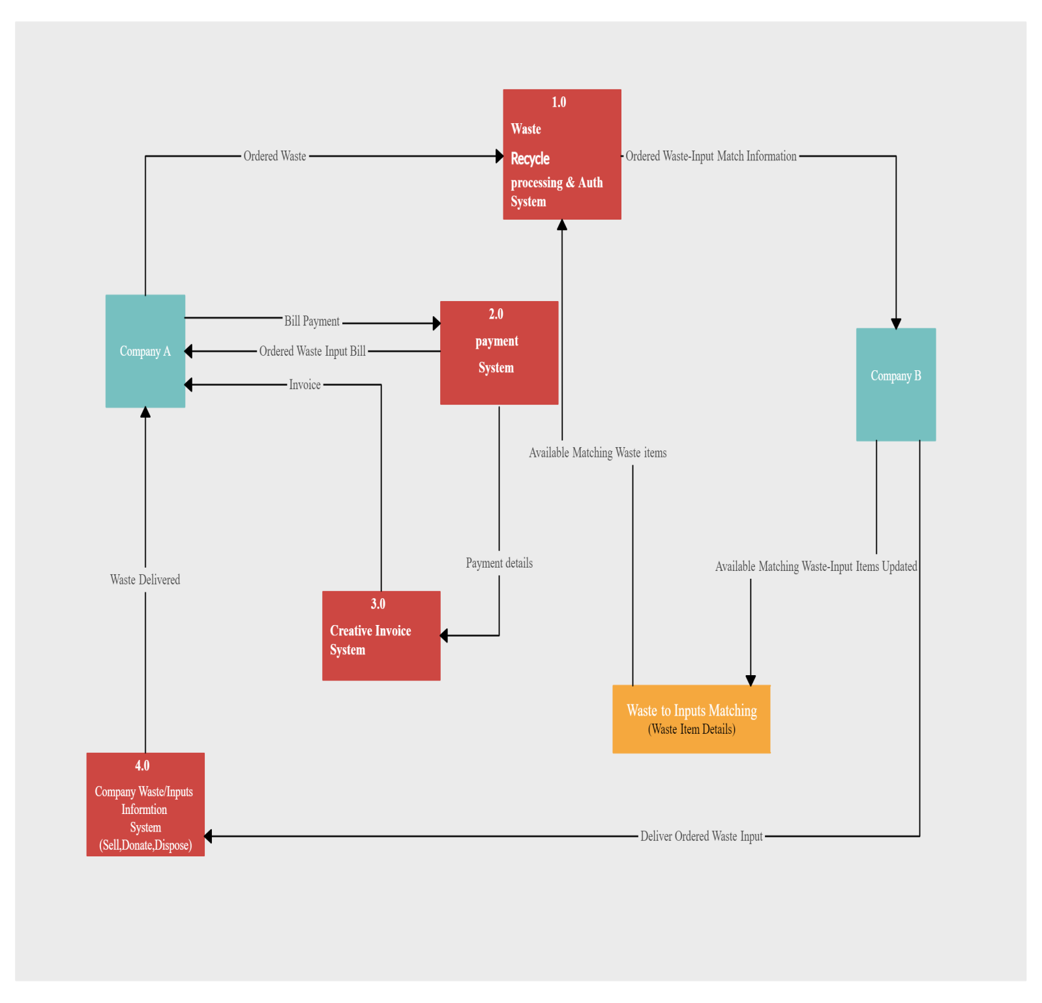

### 4.2.7 User Interface Prototypes

1. Authentication Pages: User registration and login

Figure - Login screen prototype

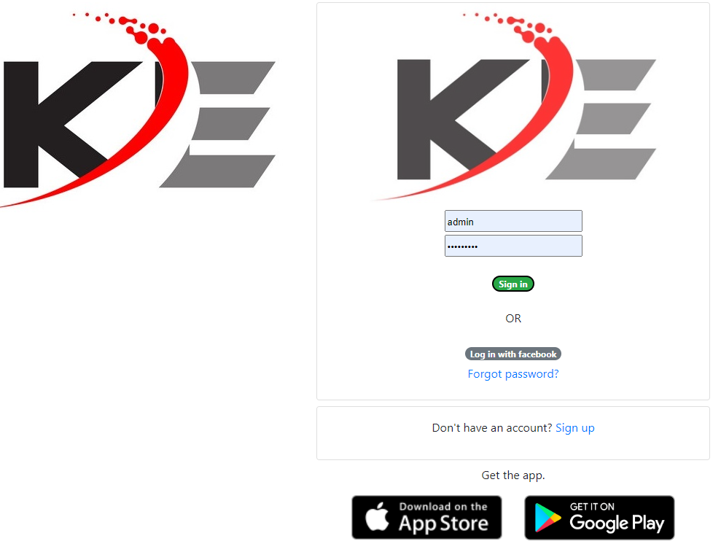

Figure - Sign up screen prototype

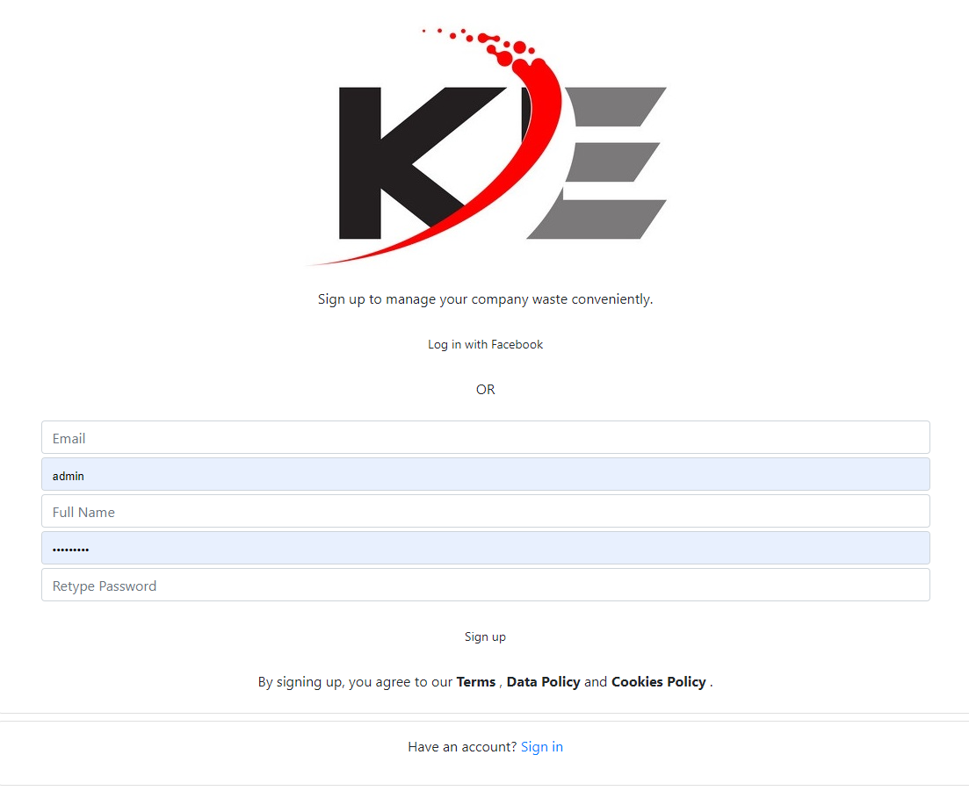

1. Dashboard: Data visualizations, graphs, and histograms

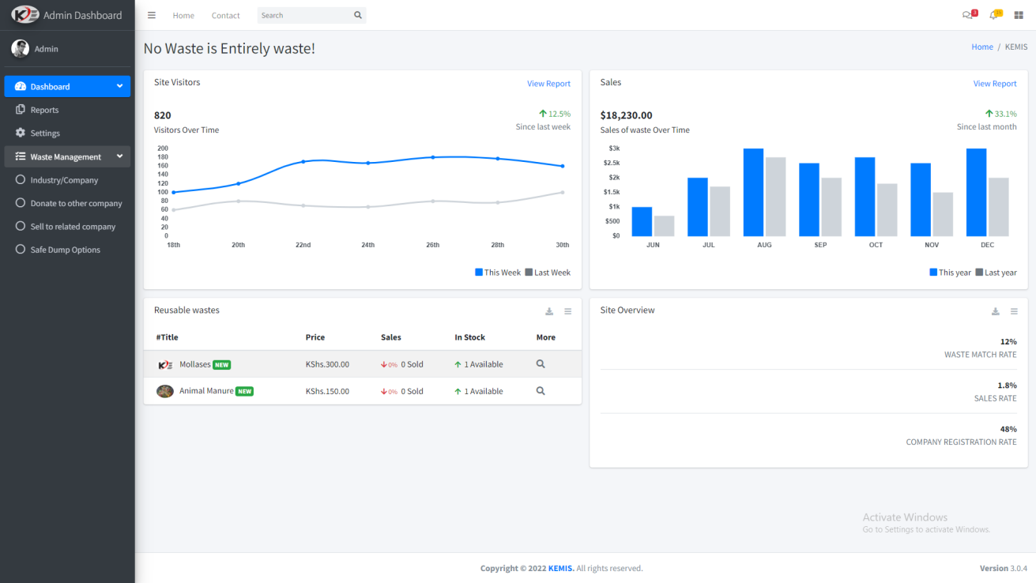

*Figure 6: User interface Dashboard prototype*

1. Company setup: Add, edit, delete, update.

Figure - Company setup screen

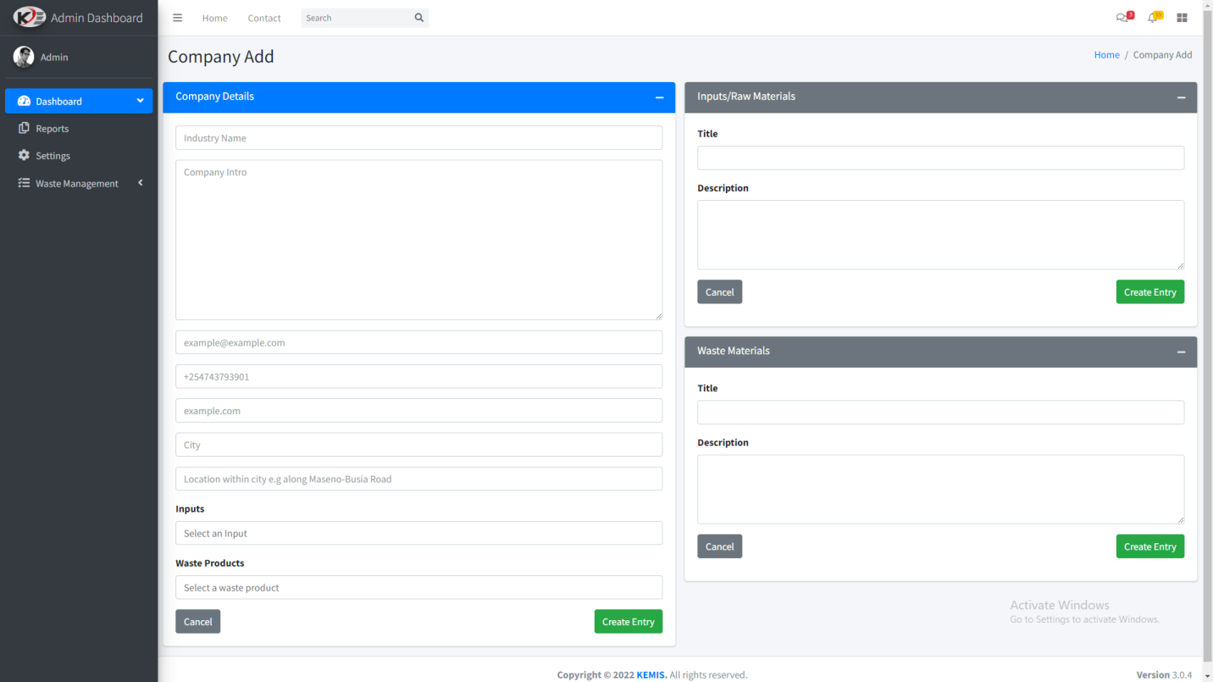

1. Waste management process execution, initialize, match, donate, sell

Figure - Initiate Waste recycle

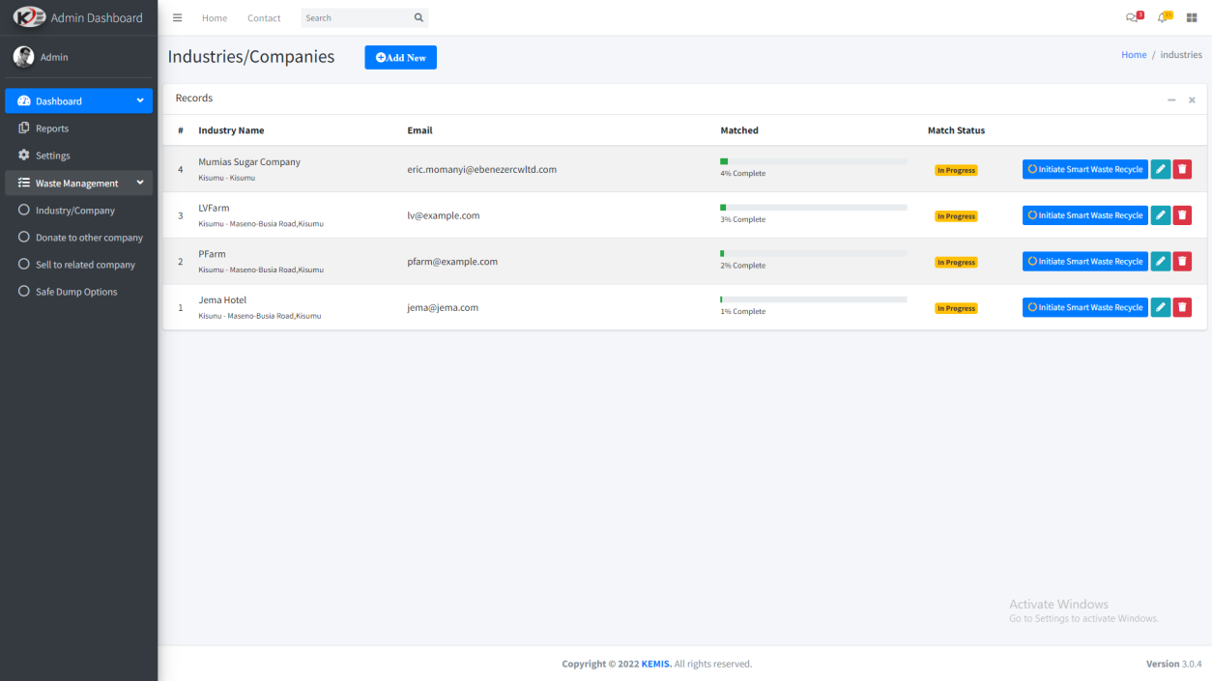

**V) Waste Matching: Match,donate,sell**

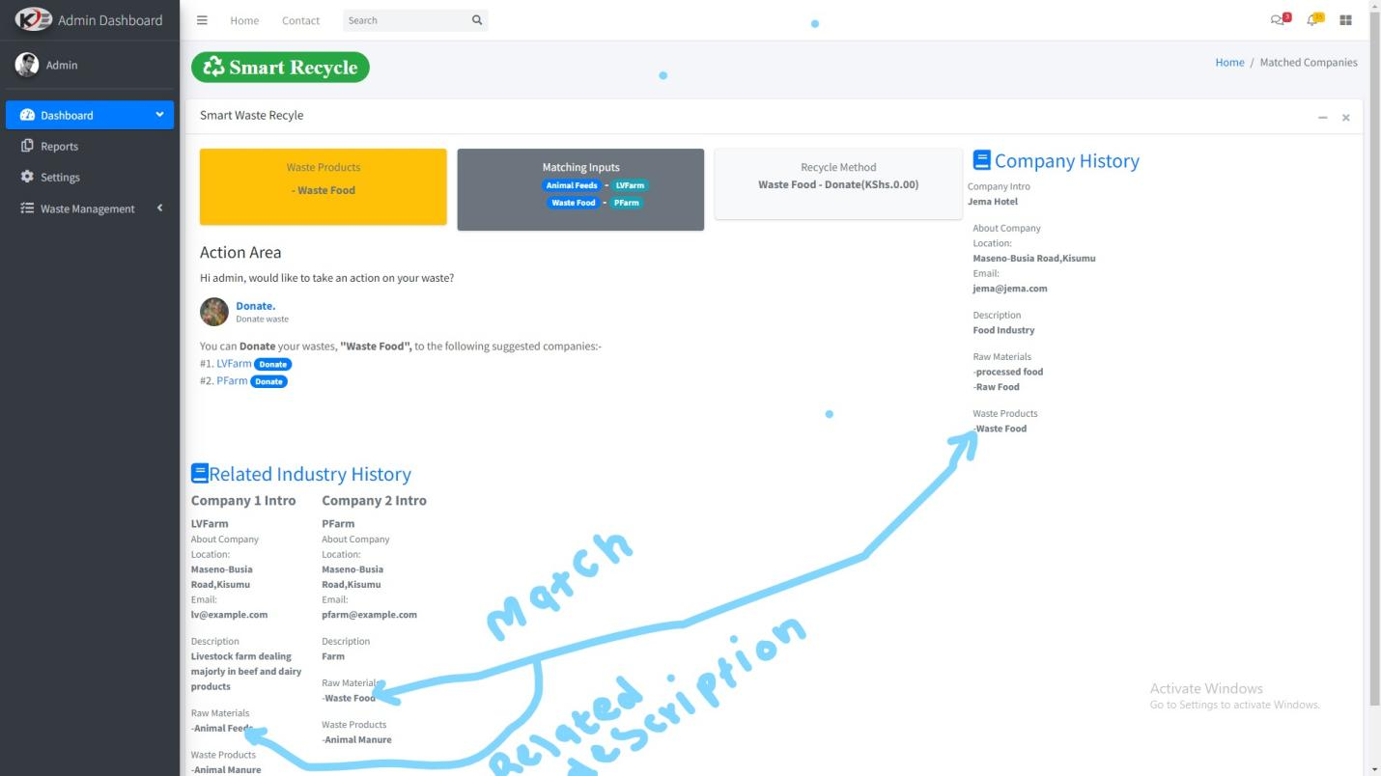**]**

### 4.2.8 ER Diagram

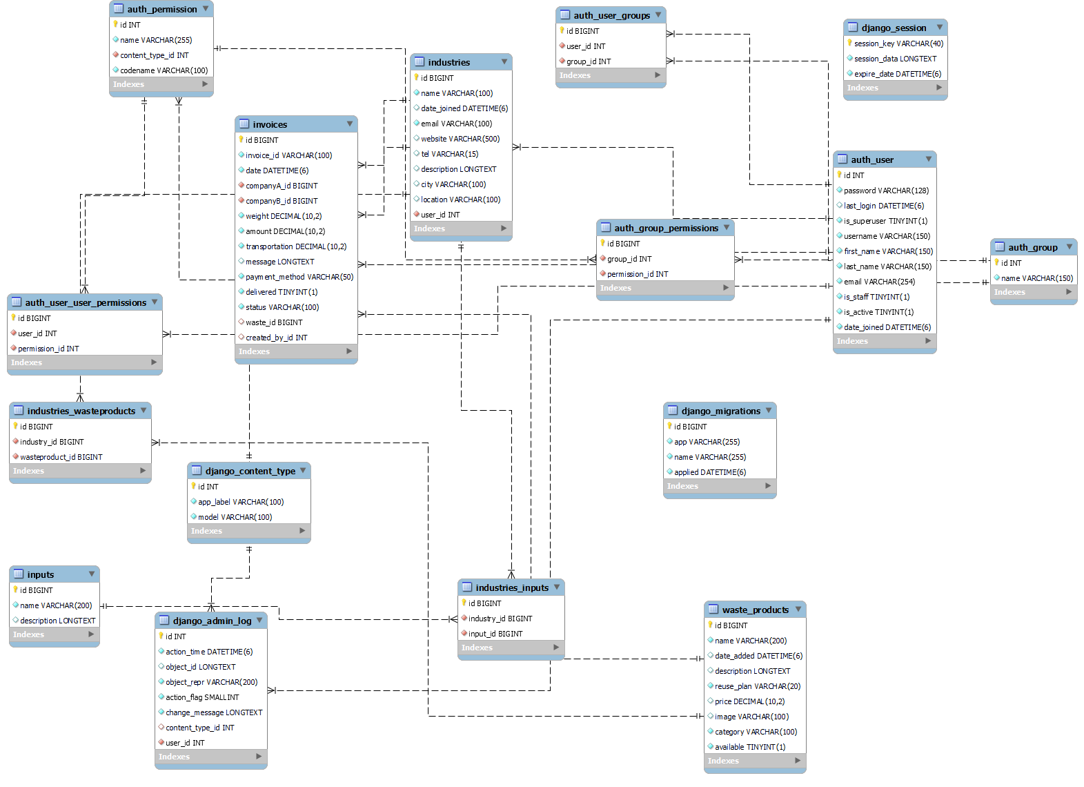

Figure  Database Design

## 4.3 Resources

Every project requires resources to aid its processes. This project is no different, it utilized resources like a good computer, writing tools, data collection, and research knowledge to carry out its activities, and collect and analyze the collected data through tools like excel and SPSS.

## 4.4 Development Environment: Hardware & Software Platform

This study involved conducting a feasibility study about existing ERP systems and web scraping software in order to come up with an advanced ERP system. The project prototype needs certain hardware and software specifications to work seamlessly and flawlessly. The following are the requirements: -

**Hardware requirements**

1. At least 4GB ram
2. At least 500GB HDD/SSD storage
3. A processor speed of not below 2.0 GHz
4. At least a corei3 x64 computer-based processor

**Software Requirements**

1. Windows/Unix operating system
2. MySQL 8.0 and later or MSSQL 2012 and later - The system is cross-platform and can run on either windows or Unix systems.
3. Python 3.7.x - Python 3 is the latest release with latest tools and libraries suitable for the project requirements.
4. The latest versions of Matplotlib, pandas, and web drivers

**Programming language and tools**

1. **Python**

Python is an interpreted, object-oriented, high-level programming language with dynamic semantics. Its high-level built in data structures, combined with dynamic typing and dynamic binding, make it very attractive for Rapid Application Development, as well as for use as a scripting or glue language to connect existing components together. Python's simple, easy to learn syntax emphasizes readability and therefore reduces the cost of program maintenance. Python supports modules and packages, which encourages program modularity and code reuse.

Due to these suitable features, the language was used to develop the business logic of the software.

1. **Django**

Django is a high-level Python web framework that encourages rapid development and clean, pragmatic design. Built by experienced developers, it takes care of much of the hassle of web development, so you can focus on writing your app without needing to reinvent the wheel. It’s free and open source.

Django was used to develop the front-end logic for the system due to its outstanding features.

1. **HTML**

As usual, web applications depend on for user interface design and implementation and sine the system is web based, HTML was an excellent choice to design the user interfaces.

1. **CSS**

HTML alone cannot achieve GUI standards for web based systems. This is where CSS, Cascading Style Sheets comes in to design what sits where, how and appearance on the web page.

1. **Bootstrap**

Bootstrap is a potent front-end framework used to create modern websites and web apps . It is open-source and free to use, yet features numerous HTML and CSS templates for UI interface elements such as buttons and forms. Bootstrap also supports JavaScript extensions. The project employed the use of bootstrap in GUI design as a supplement to custom CSS files.

1. **MySQL Database**

MySQL is a relational database management system based on SQL - Structured Query Language. The application is used for a wide range of purposes, including data warehousing, e-commerce, and logging applications. The most common use for MySQL however, is for the purpose of a web database and that is what made it an excellent choice for this project.

## 4.5 Systems Testing & Validation

System testing and module functionality inspection is the most important part of Software testing. It determines whether a system conforms to its intended purposes. This is where system bugs are identified and fixed. The system will be installed on test servers online, and a demo site and login credentials will be created for a wide range of authorized individuals from different industries and companies to log in using test credentials and run the demo system as a test prototype. The findings and suggestions will be collected for fine-tuning and further improvement. Personal level and small group testing will also be encouraged to ensure diverse testing and success.

# **CONCLUSION**

Proper waste management system is a major deficiency in most local industries in Kenya. It is difficult for industries to properly dispose of their waste or use them to make more income by selling them as raw materials to related companies. To solve the above-stated shortcomings, a system that can perform web scraping across the internet and common social media platforms is put in place to collect, analyze, visualize, and disseminate the information to both the county and national governments on current local existing industries, their end waste product, and suggest secure ways of disposing of off the waste if it cannot be recycled but most importantly identify related industries that may utilize as part of their raw material. The company in question can then sell their waste product in the form of raw material and earn more income. The information provided by the system also helps set up related industries close to each other to avoid transport costs for transferring the waste from one company to another that uses it as raw material.

**LIST OF REFERENCES**

1. Akhtar, D.M.I., 2016. Research design. Research Design (February 1, 2016).
2. Algehed, J. (2015). *Sustainable Consumption: A Knowledge Base*. Mistra. http://mistra research.se/publikationer/forstudier/sustainable-consumption---a-knowledge-base.html
3. Baker, R.S.J.D. &Yacef, M. (2009). The State of Educational Data Mining in 2009: A Review and Future Visions.
4. Benzzine, A., 2022. (System Development methodologies: a framework for comparison). [online] Umsl.edu. Available at: <http://www.umsl.edu/~sauterv/analysis/488_f02_papers/methodologies.html> [Accessed 8 March 2022].
5. Criminology Conference. Landers, R.N., Brusso, R.C., Cavanaugh, K.J., &Collmus, A.B. (2016).
6. Hanson, C., Lipinski, B., Robertson, K., Dias, D., Gavilan, I., et al. (2016). *Food Loss and Waste Accounting and Reporting Standard*. Food Loss and Waste Protocol. https://www.wri.org/sites/default/files/REP_FLW_Standard.pdf
7. Fossey, E., Harvey, C., McDermott, F. and Davidson, L., 2002. Understanding and evaluating qualitative research. Australian & New Zealand Journal of Psychiatry, 36(6), pp.717-732.
8. Gamino, A. and Parker, D., 2009. Use case diagrams in support of use case modeling: Deriving understanding from the picture. Journal of Database Management (JDM), 20(1), pp.1-24.
9. Godfray, C. and Jahn, M. (2014). *Priority Research Topics That Address Food System Knowledge Gaps to Improve the Lives of the World’s Poor*. Report to the CGIAR Mid-Term Review (MTR) Panel. CGIAR Research Program on Climate Change, Agriculture and Food Security. http://bit.ly/1t2QygH
10. Hoffer, Jeffrey A., George, Joey F., and Valcich, Joseph S. Modern Systems Analysis & Design,
11. Malik, R.S., Ahmad, S.S., and Hussain, M.T.H., 2019, March. A review of agile methodology in IT projects. In Proceedings of 2nd International Conference on Advanced Computing and Software Engineering (ICACSE).
12. McGuirk, P.M. and O'Neill, P., 2016. Using questionnaires in qualitative human geography.
13. Washington, DC: CCE. Duane, M., Reimal, E., & Lynch, M. (2017). Criminal Background Checks and Access to Jobs: A Case Study of Washington, DC. Urban Institute; Washington, DC. Eads, D. (2017, July 24).
14. Wasson, C., 2006. System analysis, design, and development. Hoboken, New Jersey.

# APPENDICES

## APPENDIX 1

**Work Plan**

|  |  |  |  |  |  |  |  |  |  |
| --- | --- | --- | --- | --- | --- | --- | --- | --- | --- |
| **Activities** |  | **July**  **2022** | **August 2022** | **September**  **2022** | **October**  **2022** | **November 2022** | **December 1**  **December 7**  **2022** | **December 8 -December 30**  **2022** | **January 1 January** **7 2022** |
| **Develop Research topic, objectives and questions** |  |  |  |  |  |  |  |  |  |
| **Work on literature review.** |  |  |  |  |  |  |  |  |  |
| **Work on methodology.** |  |  |  |  |  |  |  |  |  |
| **Proposal Development** |  |  |  |  |  |  |  |  |  |
| **Proposal presentation and pretesting of tools** |  |  |  |  |  |  |  |  |  |
| **Implementation and Coding** |  |  |  |  |  |  |  |  |  |
| **Testing and review** |  |  |  |  |  |  |  |  |  |

## APPENDIX 2

### Research questions

Industrial Waste Management Survey

Most industries experience problems when it comes to managing their resources such as waste, excess produce, excess raw materials, and so on. This gap often leads to high overheads in waste management and disposal. In addition, it also promotes environmental degradation if the waste is not properly disposed of.

This survey aims at solving this problem. Your input will be highly appreciated.

1. Name *
2. Phone *
3. Email *
4. Company (Company you were attached to if you are a student)
5. Has your company ever experienced problems with waste management before?

*Mark only one oval.*

Yes

No

Maybe

1. How does your company manage its waste? Briefly describe.
2. How does your company organize for waste disposal in case of waste that they cannot recycle? Briefly describe.
3. Has your company ever experienced an overproduction or under-production problem before?

*Mark only one oval.*

Yes

No

Other:

If yes, state how the excess production was handled.

1. How does your company manage waste from your industry?
2. Has your company ever used an advanced EMIS (Environmental Management Information) software to manage their waste before?

*Mark only one oval.*

Yes

No Maybe

Other:

1. If yes, briefly state the key functionalities that the system had/has.
2. How would your company prefer a software that manages their waste products?

*Mark only one oval.*

1 2 3 4 5

1. Suggest any key features that you would want such a system to have

## APPENDIX 3

Project Budget

|  |  |  |
| --- | --- | --- |
| NO. | TYPE OF COST | TOTAL PRICE (KSHS) |
| 1 | Transportation Costs | 10,000 |
| 2 | Printing and Binding Costs | 1100 |
| 3 | Communication | 500 |
| 4 | Browsing Cost | 500 |
|  | TOTAL COST | 12100 |
|  |  |  |

Table  Project Budget